Autentikasi Admin & Library UI
1. Instal Laravel Breeze via Composer:
composer require laravel/breeze –dev
//// --dev bukan -dev
2. Jalankan Perintah Instalasi Breeze:
php artisan breeze:install
--pilih blade
--dark mode ? NO
--framework do you prefer? 0 (PHPUnit)
Langkah Wajib Setelah Instalasi Selesai:
Setelah proses generator Breeze selesai, jalankan 3 perintah ini secara berurutan di terminal:
php artisan migrate
npm install
npm run build
Membuat FoodController untuk mengelola logika CRUD Master Makanan (Sisi Admin) beserta fitur Upload Gambar dan Validasi Input
Isi File app/Http/Controllers/FoodController.php
Buka file FoodController.php dan ganti kodenya menjadi seperti di bawah ini. Kode ini sudah dilengkapi dengan inline comment (untuk memenuhi penilaian unit Dokumentasi)
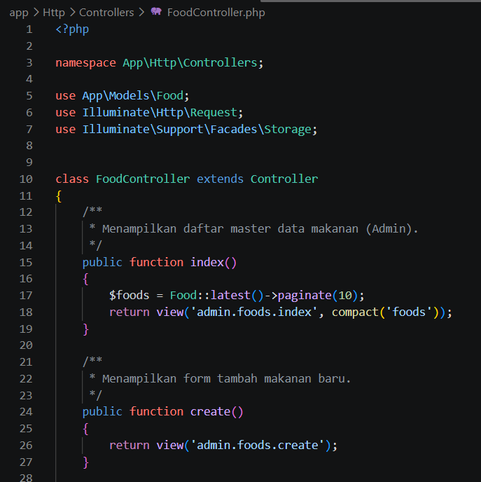
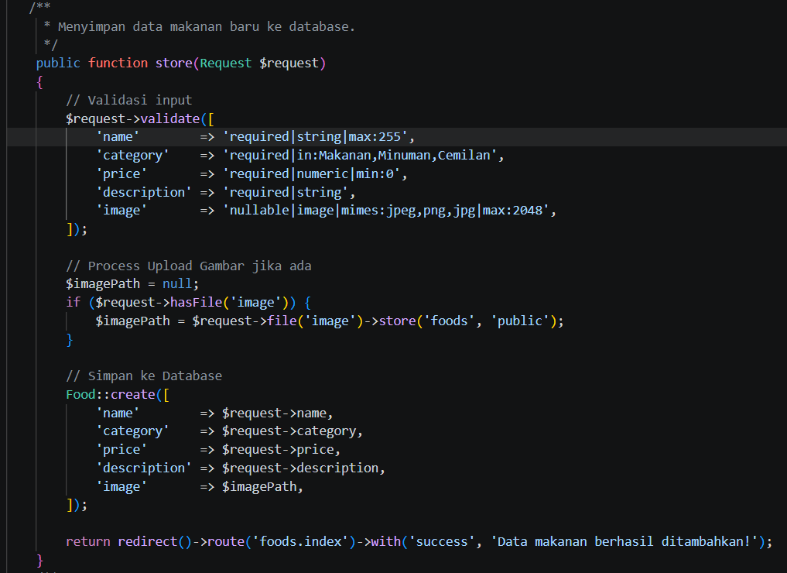
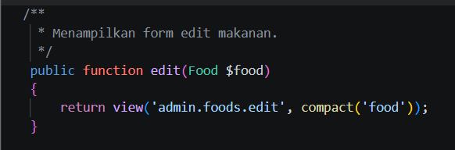

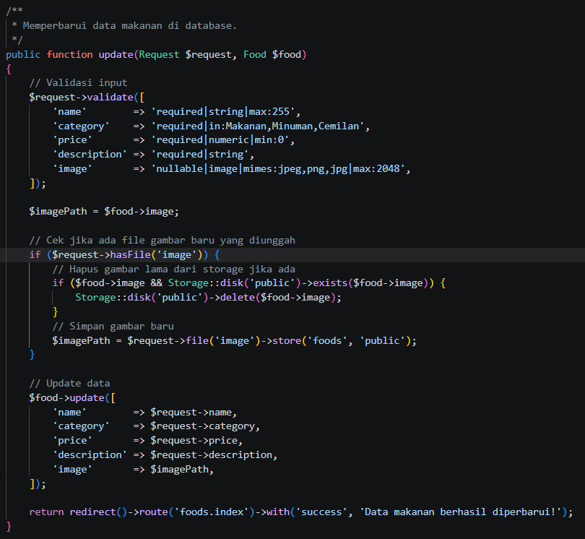

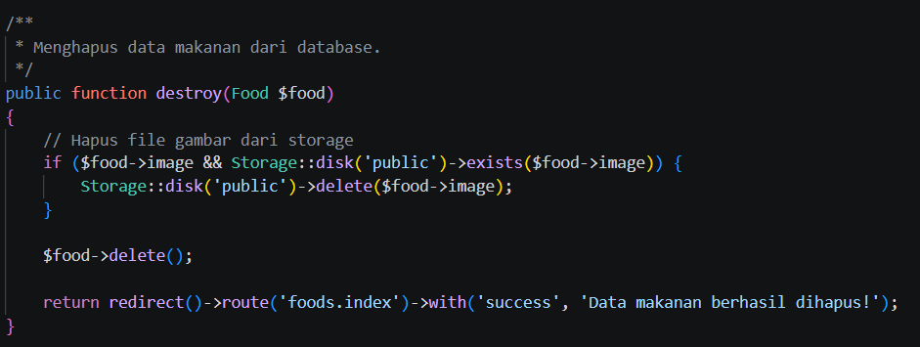

Sekarng kita membuat tampilannya
Buat folder baru di resources/views/admin/foods/, lalu buat 3 file Blade berikut:

resources/views/admin/foods/index.blade.php (Daftar Makanan)
<x-app-layout>
<x-slot name="header">
<h2 class="font-semibold text-xl text-gray-800 leading-tight">Master Data Makanan</h2>
</x-slot>

<div class="py-12 max-w-7xl mx-auto sm:px-6 lg:px-8">
<a href="{{ route('foods.create') }}" class="bg-blue-500 text-white px-4 py-2 rounded mb-4 inline-block">+ Tambah Makanan</a>

@if(session('success'))
<div class="bg-green-100 text-green-700 p-3 rounded mb-4">{{ session('success') }}</div>
@endif

<table class="w-full bg-white border mt-4">
<thead>
<tr class="bg-gray-100 border-b">
<th class="p-2">Gambar</th>
<th class="p-2">Nama</th>
<th class="p-2">Kategori</th>
<th class="p-2">Harga</th>
<th class="p-2">Aksi</th>
</tr>
</thead>
<tbody>
@foreach($foods as $food)
<tr class="border-b text-center">
<td class="p-2">
@if($food->image)
<img src="{{ asset('storage/' . $food->image) }}" class="w-16 h-16 object-cover mx-auto">
@else
<span class="text-gray-400">No Image</span>
@endif
</td>
<td class="p-2">{{ $food->name }}</td>
<td class="p-2">{{ $food->category }}</td>
<td class="p-2">Rp {{ number_format($food->price) }}</td>
<td class="p-2">
<a href="{{ route('foods.edit', $food->id) }}" class="text-blue-600 mr-2">Edit</a>
<form action="{{ route('foods.destroy', $food->id) }}" method="POST" class="inline">
@csrf
@method('DELETE')
<button type="submit" onclick="return confirm('Hapus data ini?')" class="text-red-600">Hapus</button>
</form>
</td>
</tr>
@endforeach
</tbody>
</table>
</div>
</x-app-layout>

resources/views/admin/foods/create.blade.php (Form Tambah)
<x-app-layout>
<x-slot name="header">
<h2 class="font-semibold text-xl text-gray-800 leading-tight">Tambah Makanan</h2>
</x-slot>

<div class="py-12 max-w-2xl mx-auto sm:px-6 lg:px-8">
<form action="{{ route('foods.store') }}" method="POST" enctype="multipart/form-data" class="bg-white p-6 rounded shadow">
@csrf
<div class="mb-4">
<label class="block font-medium">Nama Makanan</label>
<input type="text" name="name" class="w-full border p-2 rounded" required>
</div>
<div class="mb-4">
<label class="block font-medium">Kategori</label>
<select name="category" class="w-full border p-2 rounded" required>
<option value="Makanan">Makanan</option>
<option value="Minuman">Minuman</option>
<option value="Cemilan">Cemilan</option>
</select>
</div>
<div class="mb-4">
<label class="block font-medium">Harga</label>
<input type="number" name="price" class="w-full border p-2 rounded" required>
</div>
<div class="mb-4">
<label class="block font-medium">Deskripsi</label>
<textarea name="description" class="w-full border p-2 rounded" required></textarea>
</div>
<div class="mb-4">
<label class="block font-medium">Gambar Makanan</label>
<input type="file" name="image" class="w-full border p-2 rounded">
</div>
<button type="submit" class="bg-green-500 text-white px-4 py-2 rounded">Simpan</button>
</form>
</div>
</x-app-layout>

resources/views/admin/foods/edit.blade.php (Form Edit)
<x-app-layout>
<x-slot name="header">
<h2 class="font-semibold text-xl text-gray-800 leading-tight">Edit Makanan</h2>
</x-slot>

<div class="py-12 max-w-2xl mx-auto sm:px-6 lg:px-8">
<form action="{{ route('foods.update', $food->id) }}" method="POST" enctype="multipart/form-data" class="bg-white p-6 rounded shadow">
@csrf
@method('PUT')
<div class="mb-4">
<label class="block font-medium">Nama Makanan</label>
<input type="text" name="name" value="{{ $food->name }}" class="w-full border p-2 rounded" required>
</div>
<div class="mb-4">
<label class="block font-medium">Kategori</label>
<select name="category" class="w-full border p-2 rounded" required>
<option value="Makanan" {{ $food->category == 'Makanan' ? 'selected' : '' }}>Makanan</option>
<option value="Minuman" {{ $food->category == 'Minuman' ? 'selected' : '' }}>Minuman</option>
<option value="Cemilan" {{ $food->category == 'Cemilan' ? 'selected' : '' }}>Cemilan</option>
</select>
</div>
<div class="mb-4">
<label class="block font-medium">Harga</label>
<input type="number" name="price" value="{{ $food->price }}" class="w-full border p-2 rounded" required>
</div>
<div class="mb-4">
<label class="block font-medium">Deskripsi</label>
<textarea name="description" class="w-full border p-2 rounded" required>{{ $food->description }}</textarea>
</div>
<div class="mb-4">
<label class="block font-medium">Gambar Baru (Opsional)</label>
<input type="file" name="image" class="w-full border p-2 rounded">
</div>
<button type="submit" class="bg-blue-500 text-white px-4 py-2 rounded">Update</button>
</form>
</div>
</x-app-layout>
UPDATE DATASEERDER KARENA INPUT DATA ADMIN:
use Illuminate\Support\Facades\Hash; ---TAMBA HKAN INI
// 1. Buat Akun Admin Bawaan untuk Uji Coba Asesor
User::create([
'name' => 'Admin Toko',
'email' => 'admin@gmail.com',
'password' => Hash::make('password123'),
]);
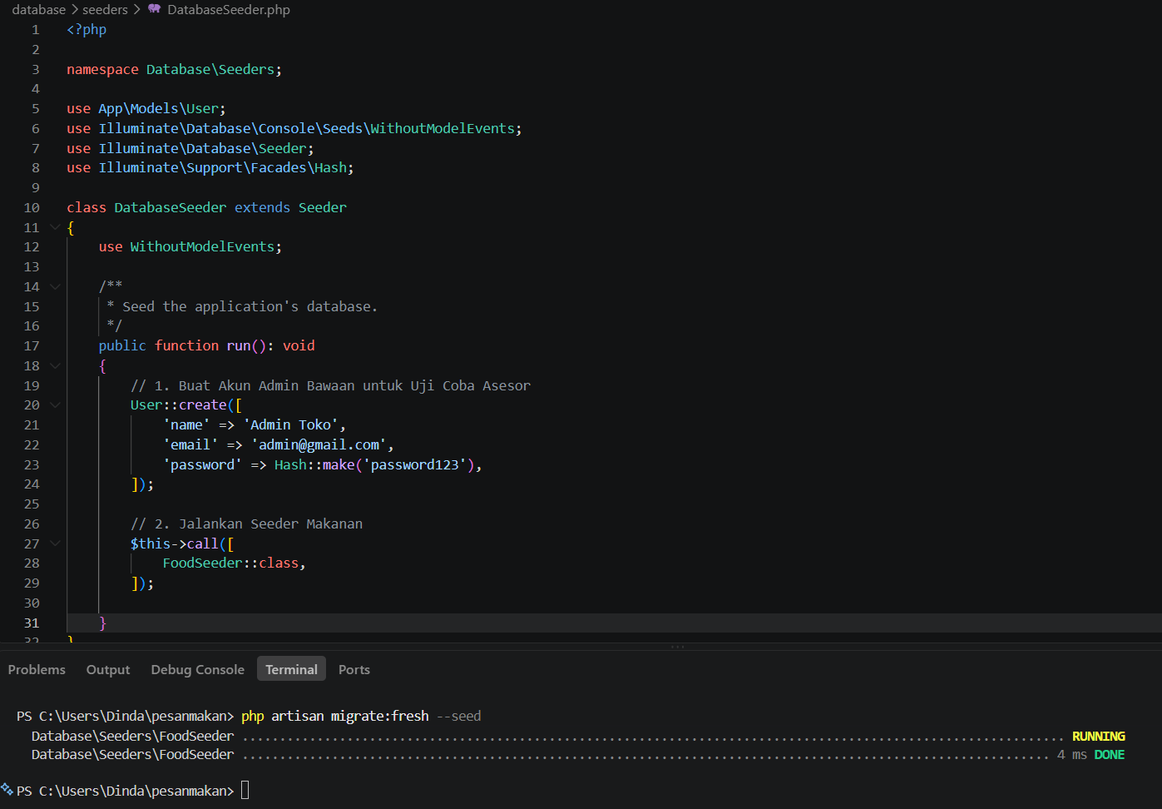

php artisan migrate:fresh –seed

Perbarui routes/web.php
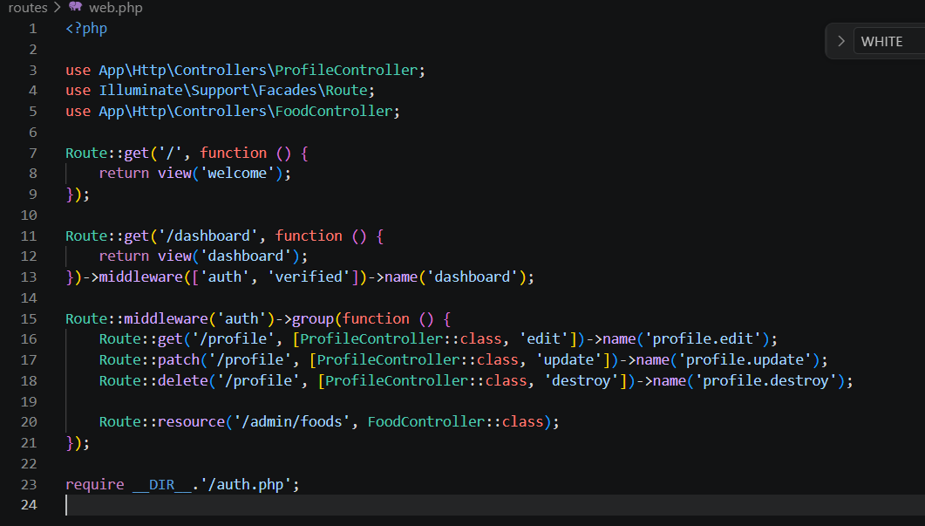
tambahkan line 3 dan line 20;
php artisan storage:link
COBA LOGIN DAN FUNGSI CRUD FOOD

